To Schedule a Computer Lab

- Open your calendar in Outlook

- Click Open Calendar and then Open Shared
Then Shared Calendar

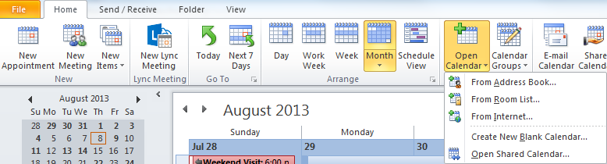

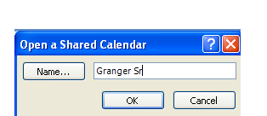

- Search for Granger Sr

- Scroll down to the “G”s and choose the shared calendar you want to open.
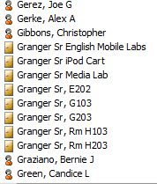

- Click on the calendar you want to open. Note, you must have at least one calendar chosen, so once you open a calendar if you only want to see that lab calendar remove the check mark under My Calendar.

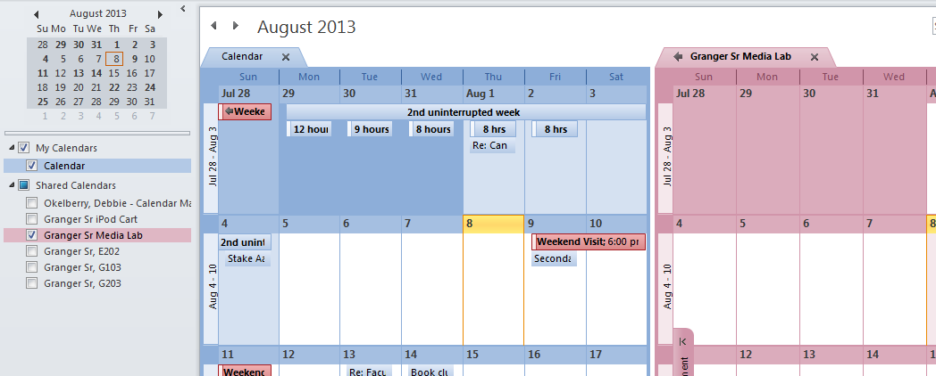

When you schedule a lab make sure you click the all day event button so that your request shows up at the top so that everyone can see it. Type your name and the class periods you will be using the lab.

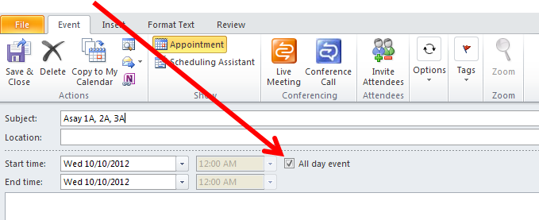

Your request will show up on top
If you select All day Event:
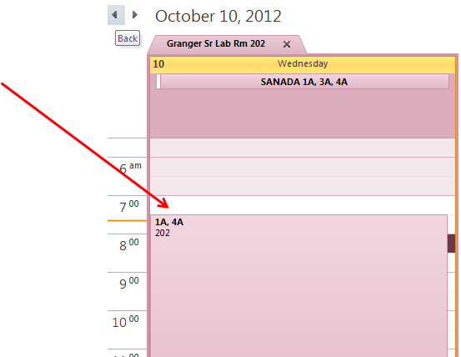

Otherwise your request shows up below and others will not see that you have scheduled the lab and then we get a lab that is double booked.

